**Mobile Application Development**

**Share Hope**



**Topic:**

Wireframes and Prototyping

**Submitted To:**

Miss Drakhshan Bokhat

**Submitted By:**

Shaheer Arshad (2020-CS-639)

M. Abdullah (2020-CS=627)

Abdul Rehman (2020-CS-640)

**Degree & Semester:**

BSCS (6th Semester)

**Department of Computer Science**

**University of Engineering and Technology, New Campus, Lahore**

**Needy**

**User Flows:**

1. Signup > Verification Wait
2. SignIn > Forgrt Password > Create New > SignIn
3. SignIn > Home Screen > View Request / Edit Request / Add Request
4. SignIn > Home Screen > View Notification
5. SignIn > Home Screen > View/Edit Profile
6. **Sign Up**

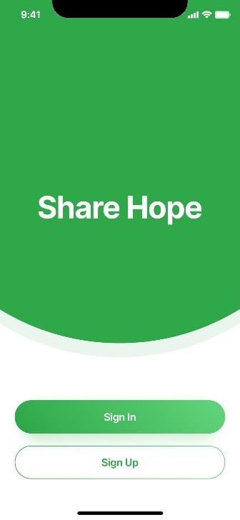 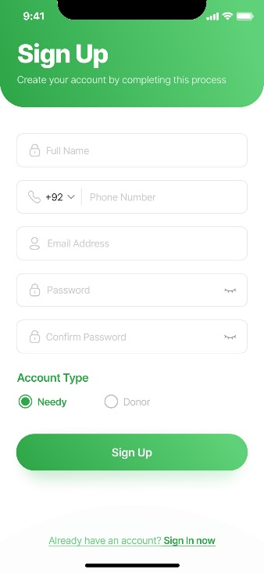 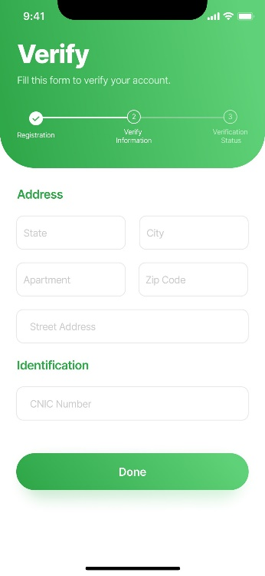 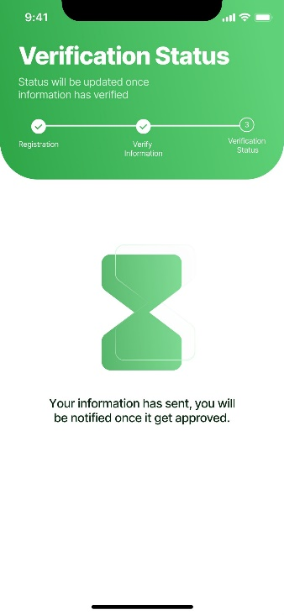

1. **Forget Password**

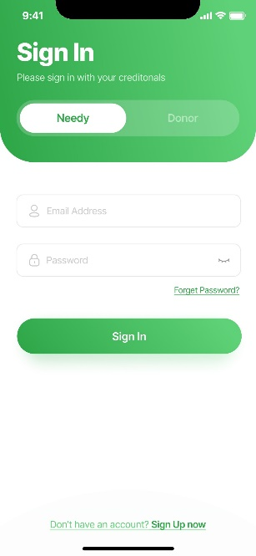 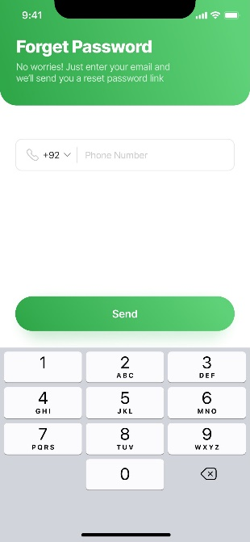 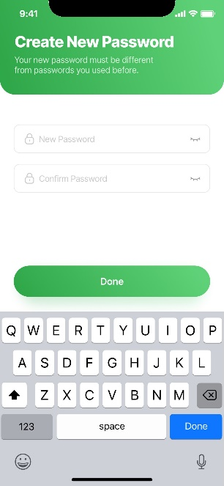

1. **Main Page**

 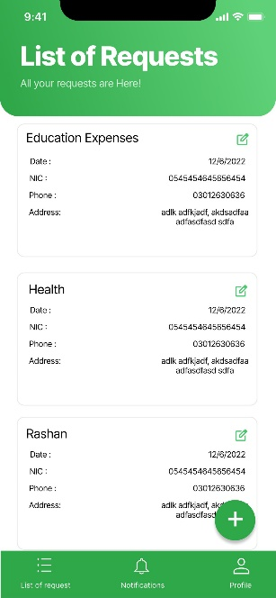 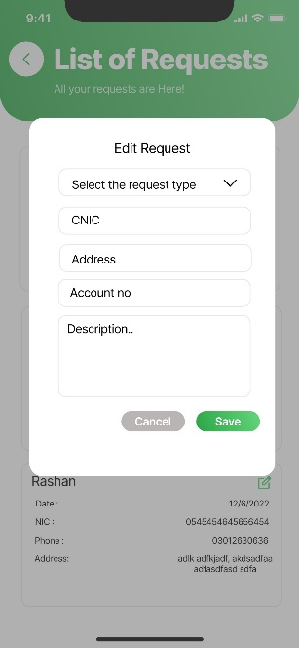 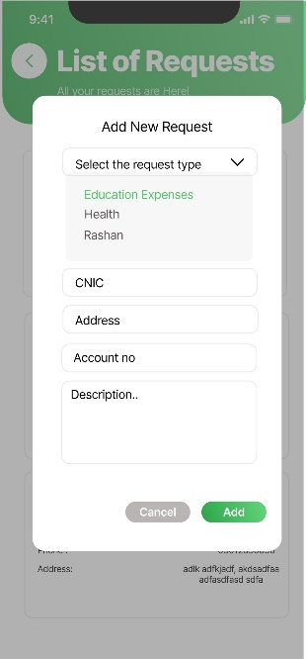

1. **View Notification**

  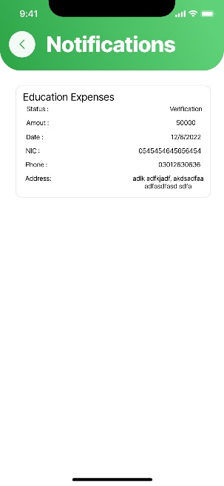

1. **View/Edit Profile**

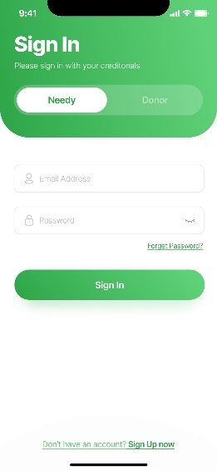 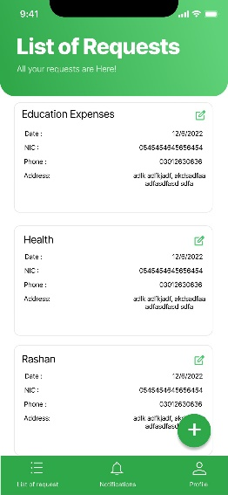 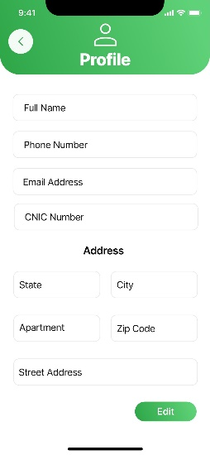

**Donor**

**User Flows:**

1. Signup > Verification Wait
2. SignIn > Forgrt Password > Create New > SignIn
3. SignIn > Home Screen > View Request > Donate
4. SignIn > Home Screen > View Donations
5. SignIn > Home Screen > View/Edit Profile
6. **Sign Up**

   

1. **Forget Password**

** ** 

1. **Donate**

 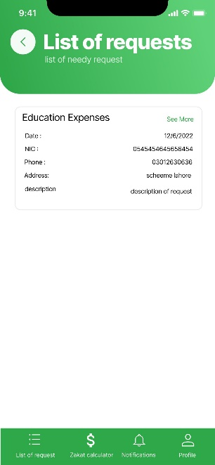 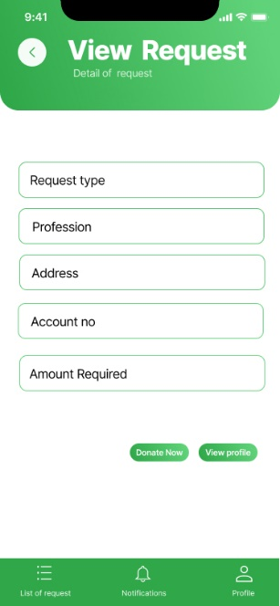 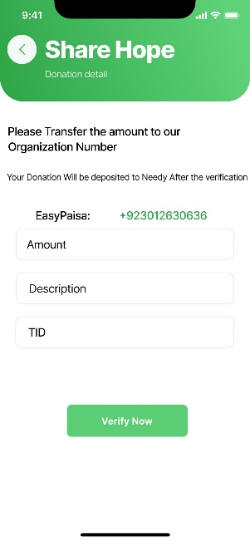

1. **View Donations**

  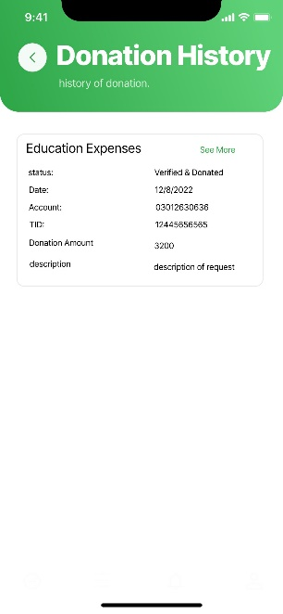

1. **View/Edit Profile**

 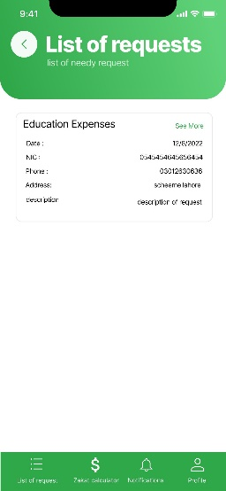 

**Admin**

**User Flows:**

1. Signup > Verification Wait
2. SignIn > Forgrt Password > Create New > SignIn
3. SignIn > Home Screen > View Request > Verify
4. SignIn > Home Screen > View Donor
5. SignIn > Home Screen > View Needy
6. **Sign Up**

   

1. **Forget Password**

** ** 

1. **Verify Request**

 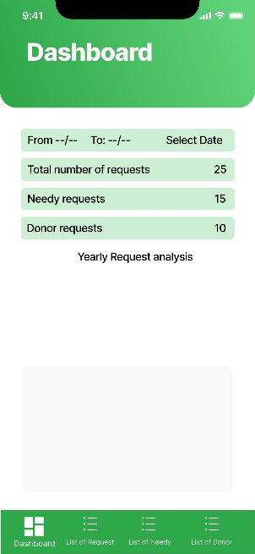 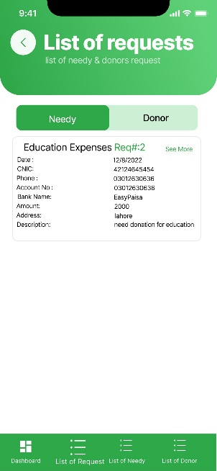 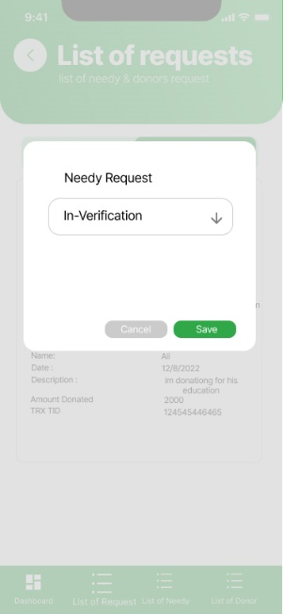

1. **View Donors**

 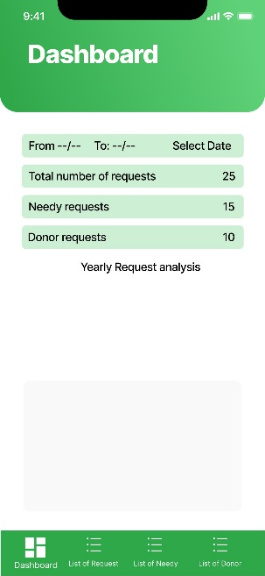 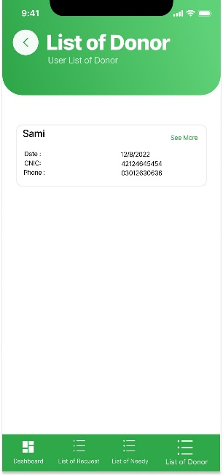

1. **View Needy**

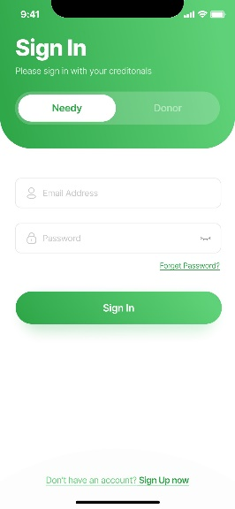 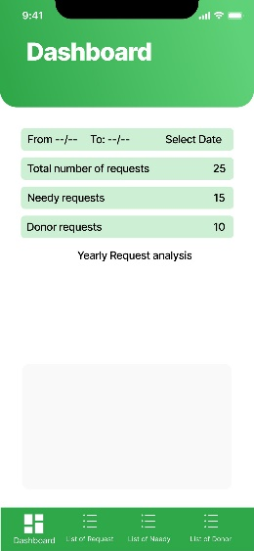 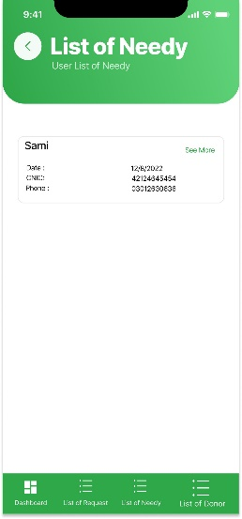

**Protypes Links**

**Needy:**

<https://www.figma.com/proto/BLT3NhnzOGRMxuStbWt7lA/Share-Hope?node-id=1-2552&scaling=min-zoom&page-id=0%3A1&starting-point-node-id=1%3A2552>

**Donor:**

<https://www.figma.com/proto/iYEmMLKtSrVcy8hLubH764/Donor-Share-Hope?node-id=2-1706&scaling=min-zoom&page-id=0%3A1&starting-point-node-id=2%3A1706>

**Admin:**

<https://www.figma.com/proto/qb1Ug008BmEdpYCV6WMK8U/Admin-Share-Hope?node-id=1-1877&scaling=min-zoom&page-id=0%3A1&starting-point-node-id=1%3A1877>